Installation of Fitpoint
Installing the four corners
When delivered in a closed truck the four corner exercises (Stepper, Twister, StepUp and BalanceBoard) will not be pre-assembled.
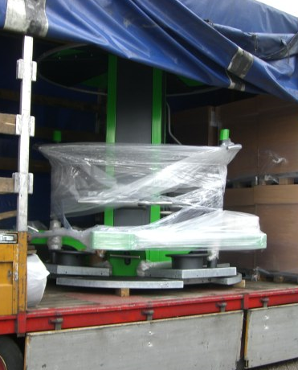
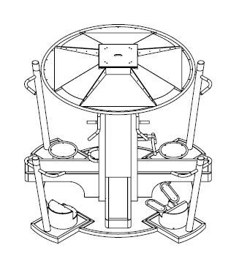
The necessary bolts, washers and lock nuts are supplied by Denfit

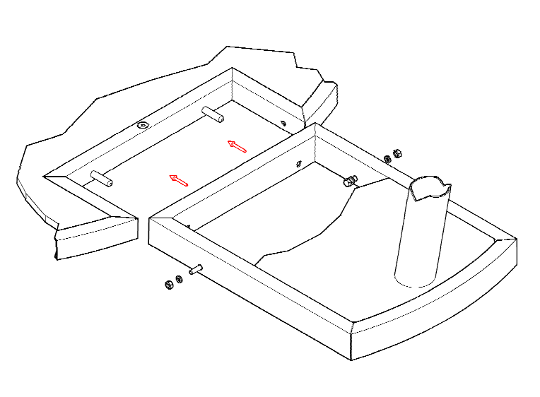

1 - Put the Fitpoint on the wooden beams that come with the delivery (image 1)
2 - Place the four corners in the right spot position (image 2)
3 - Tilt the floor backward and shove it over de pins (image 3a and b)
4 - Lift the floor on side of the post so it is parallel with the Fitpoint floor (image 4)
5 - Push the bolt through the holes from the inside and screw on the lock nut from the other side (image 5a and b)
6 - Now the floor is installed (image 6)
7 - After the four corners are installed, remove the wooden beams
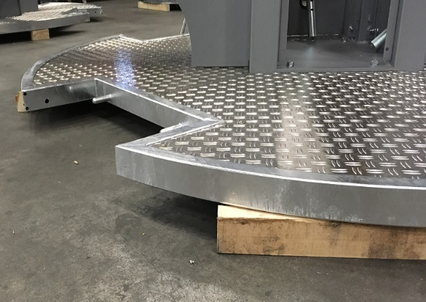
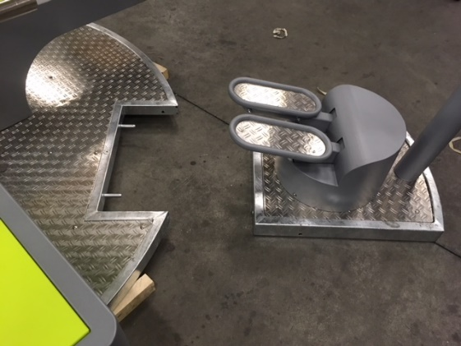
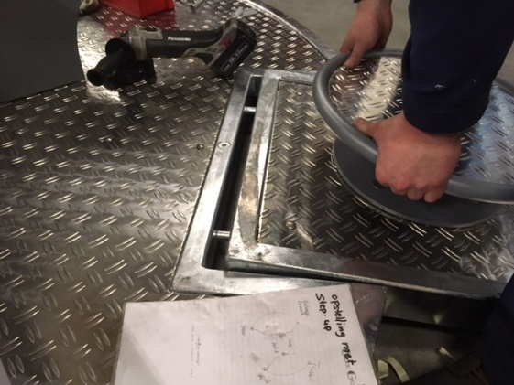
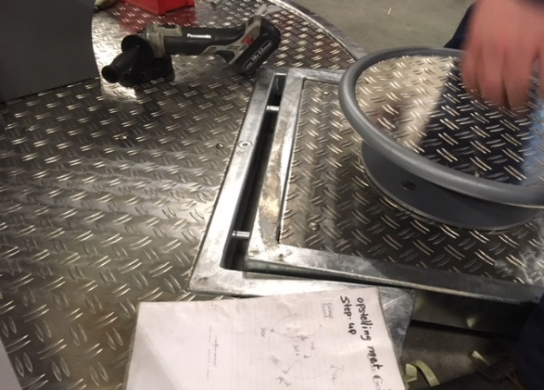
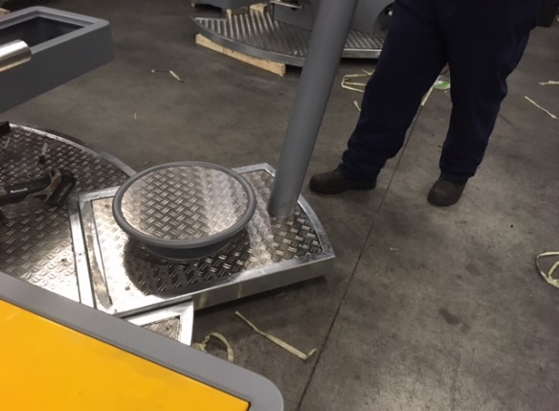
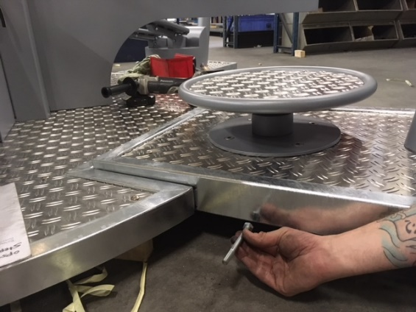

1
2

3a
3b

5a
4

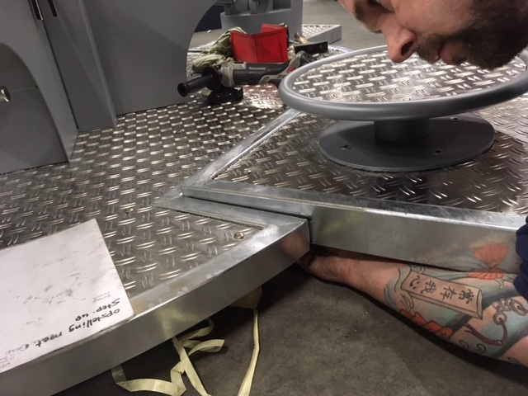
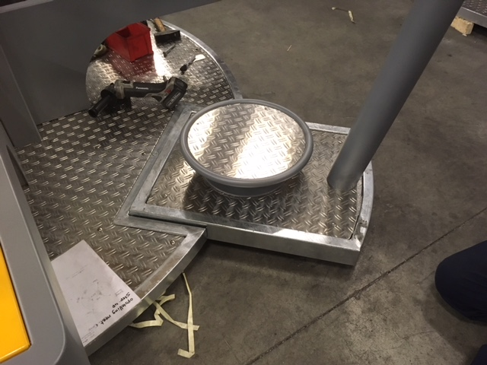
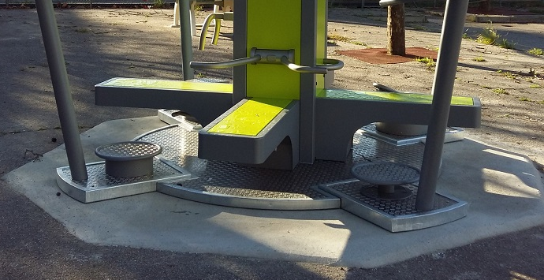
7

6
5b
Anchoring
The FitPoint has a weight of 1500 kg and therefor anchoring to the ground is not necessary. If anchoring is desirable, this is how it can be done:
Step 3
Anchoring soft surface
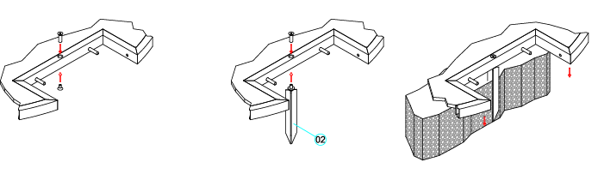
Step 2
Step 1

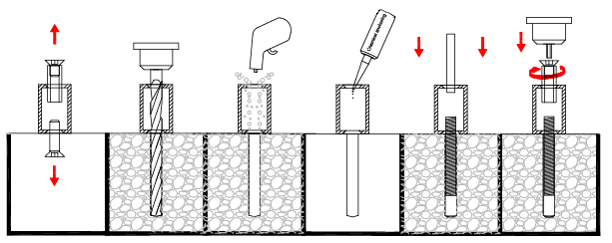
Anchoring on tarmac


Anchoring on tarmac with chemical anchoring (not provided). Use drill instructions from your chemical anchoring
Anchoring on concrete

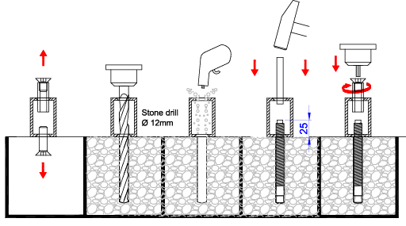

Anchoring on concrete with wedge anchors.

